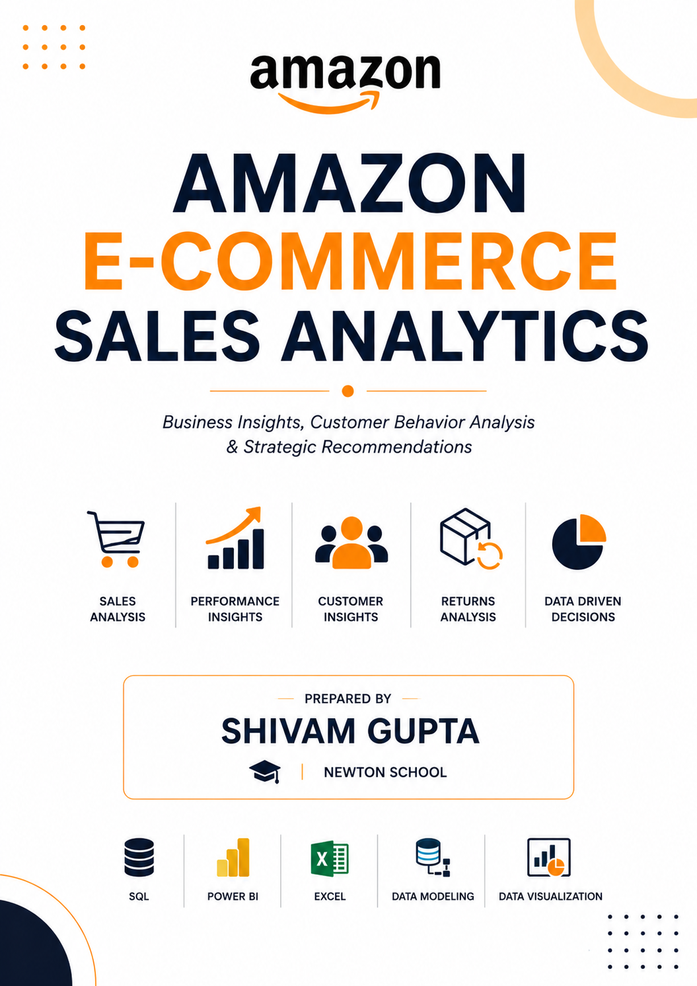

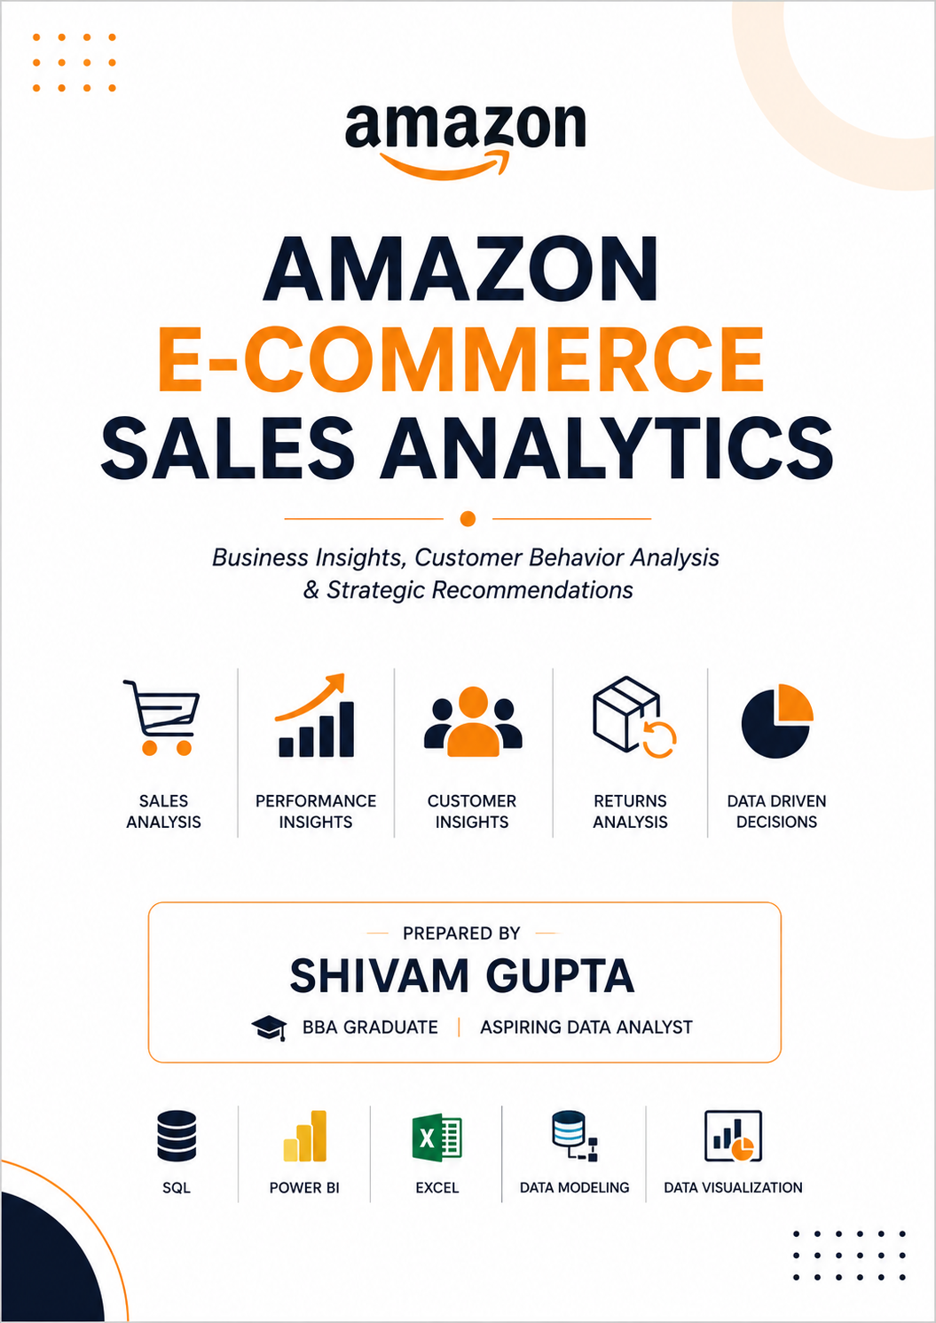
AMAZON E-COMMERCE ANALYSIS

Objective Questions
1. What is the total number of attributes in the customer table?
Ans: The Customer table contains 3 attributes (columns) that provide demographic information about customers. These attributes help in customer segmentation and analysis.
The attributes are:
- CustomerID
- Customer Age
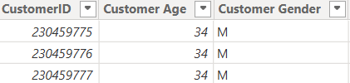
- Customer Gender
These columns were used to understand customer behavior across different age groups and genders.

2. How will you get the “Customer’s” ages in the “Order” tables according to customer IDs?
Ans: Customer Age was made available in the Orders analysis by creating a relationship between the Orders and Customers tables using the CustomerID field.
A relationship was established in the Power BI data model, allowing Customer Age from the Customers table to be accessed and used in reports, calculations, and visualizations without physically merging the tables.
This approach helps maintain a clean data model while enabling customer segmentation and demographic analysis based on age.
Relationship Used:
Customers (1)
|
|
CustomerID
|
|
Orders (Many)
Business Benefit:
- Analyze purchasing behavior by age group.
- Compare sales performance across customer segments.
- Create age-based dashboards and insights.
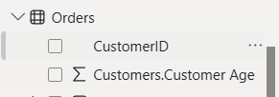
- Improve targeted marketing strategies.

3. In analyzing the dataset with Power BI, ensure data cleaning to address inconsistencies and missing values before further analysis.
Ans: Data cleaning was performed to ensure accuracy and reliability of analysis.
The following cleaning activities were completed:
1. Null Value Check
The dataset was checked for missing values.
Findings:
- Product Category → 1 Null Value
- Unit Price → 8 Null Values
- Order Quantity → 8 Null Values
- Reason → 83,355 Null Values
The Reason column contains null values because many orders were successfully delivered and therefore no return reason was recorded.
2. Duplicate Check
Duplicate records were checked in both Orders and Customers tables.
Result:
- Orders Table → No Duplicates Found
- Customers Table → No Duplicates Found
3. Data Type Validation
Data types were verified and corrected where required.
Examples:
- OrderDate → Date
- Delivery Date → Date
- Unit Price → Decimal Number
- Sale Price → Decimal Number
- Order Quantity → Whole Number
4. Data Integration
Customer Age was merged from Customers table into Orders table using CustomerID.
5. Feature Creation
A new column named Delivery Days was created to calculate delivery time.

4. How can we calculate the total revenue generated by all the sales?
Ans: The total revenue generated from all sales was calculated using a DAX measure in Power BI.
The SUM() function was used to add all values from the Sale Price column.
DAX Measure:
TotalRevenue=
SUM(Orders[SalePrice])
Result:
The total revenue generated from all sales is:
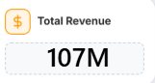
107.24 Million
This KPI helps evaluate overall business performance and sales growth.

5. What is the total number of unique customers who made purchases each year? Is there any increase in the number over the years?
Ans: The DISTINCTCOUNT() function was used to calculate unique customers for each year.
Customer Count by Year:
Year | Unique Customers
2015 | 17,624
2016 | 17,634
2017 | 17,672
2018 | 17,354
2019 | 17,537
2020 | 25,179
Insight:
The number of customers remained relatively stable from 2015 to 2019 and increased significantly in 2020, indicating strong customer acquisition and higher market demand.
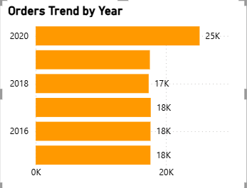
2019 the growth is around 7.7k customers.

6. How can we determine the total number of unique products available in the company?
Ans: To determine the total number of unique products available in the company we must use DAX function named DISTINCTCOUNT() which gives the count of distinct products in the data. I have created New Measure “Unique Products” to find the count of unique products available.
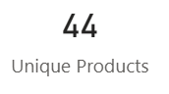
DAX: Unique Products = DISTINCTCOUNT(Orders[Product])

There 44 total number of unique products available in the company.

7. What is the average number of days it takes for products to be delivered, get the metric for only the delivered orders.
Ans: To find the average number of days it takes for products to be delivered, I have created New Calculated Column “Delivery Days” which is the difference between the order date and delivery date of the product to find this I have used DATEDIFF() dax function.
DAX: Delivery Days = DATEDIFF(Orders[OrderDate], Orders[Delivery Date], DAY)
Using the calculated column I found the average number of days for delivery by using CALCULATE() and AVERAGE() dax functions named as “Avg Delivery Days”
DAX: Avg Delivery Days = CALCULATE(
AVERAGE(Orders[Delivery Days]),
Orders[Status] = "Delivered"
)
The above dax function calculates the average no.of delivery Days the function CALCULATE() calculates the average of delivery days only for the products with the status as Delivered.
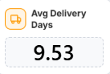
The average number of days it takes for products to be delivered for the products with status delivered is 9.53 days.

8. Which products, categories, and subcategories are the most popular?
Ans: Product popularity was measured using order count and quantity sold.
The most popular categories were:
- Phones & Tablets
- Electronics
- Fashion
These categories generated the highest customer demand and contributed significantly to overall sales volume.
Insight:
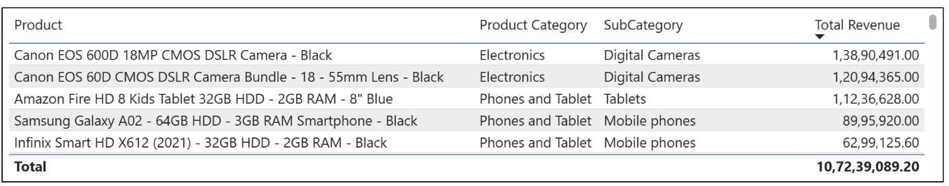
Phones & Tablets consistently received the highest number of orders, making it the most preferred category among customers.

9. Which products have seen an increase or decrease in sales over the year?
Ans: Revenue trends were analyzed across different product categories from 2015 to 2020 to identify growth patterns and changing customer preferences.
Findings:
- Electronics showed steady growth throughout the period and experienced a significant increase in revenue in 2020.
- Health & Beauty generated the highest revenue among the displayed categories and maintained consistent growth over the years.
- Fashion remained relatively stable between 2015 and 2019, followed by noticeable growth in 2020.
- Most product categories experienced a sharp increase in revenue during 2020, indicating stronger customer demand and market expansion.
Insight:
The analysis shows that technology-related and consumer-focused categories experienced the strongest growth over time. The substantial increase in revenue during 2020 suggests higher customer purchasing activity and growing demand across multiple product categories.
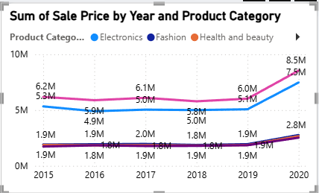
Conclusion: Electronics and Health & Beauty were among the fastest-growing categories, while Fashion demonstrated stable performance with moderate growth. These categories can be considered key contributors to future business growth.

10. While modeling the data relationships, what will be the type of relationship between the customer ID of Orders and customer tables?
Ans: While modelling the data relationship between Orders and customers tables on CustomerID, the type of relationship is Many-to-One. The relationship tells that there are two or orders placed by a single customer from the Customers table.
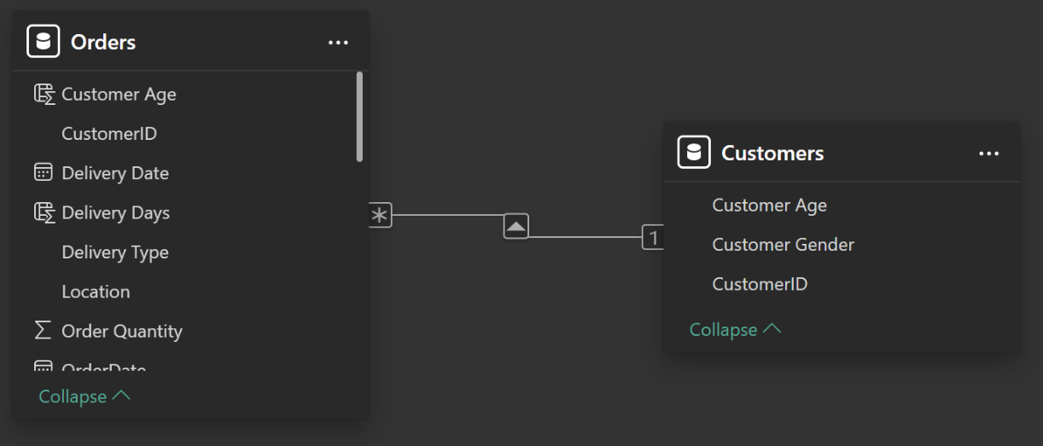
The above image is the relationship diagram between Orders and Customer tables.

11. How have you handled the null values in the data?
Ans: Yes, a few missing values were identified during data cleaning.
Null Value Summary:
Column | Null Count
Product Category | 1
Unit Price | 8
Order Quantity | 8
Reason | 83,355
Explanation: The large number of null values in the Reason column is expected because only returned orders contain a return reason. Delivered orders do not require a reason field.

12. Were there any data format issues in the data, and if there were/are how you would handle them?
Ans: No major formatting issues were found in the dataset.
However, data types were reviewed and validated to ensure proper analysis.
Verified Data Types:
Column | Data Type
OrderDate | Date
Delivery Date | Date
Unit Price | Decimal
Shipping Fee | Decimal
Sale Price | Decimal
Order Quantity | Whole Number
Rating | Decimal
Proper formatting ensured accurate calculations and visualizations in Power BI.

13. When we add a column in Power Query what’s the code that comes in M language in the formula bar? What do you know about M-query?
Ans: I have added new column “Delivery Days” in Power Query the generated M language code is shown below.
= Table.AddColumn(#"Renamed Columns", "Delivery Days", each [OrderDate] - [Delivery Date])
- M-query is a Power Query language usually called as M language, it is used to transform, clean and shape the data before loading it to the Power BI.
- M language follows step by step process building each step upon another to transform the data, and it holds each step performed in the history, also M language is a case sensitive so one must be careful while working with M-query.
14. Identify the top 5 most valuable customers using a composite score that combines three key metrics: (SQL)
Total Revenue (50% weight): The total amount of money spent by the customer.
Order Frequency (30% weight): The number of orders placed by the customer, indicating their loyalty and engagement.
Average Order Value (20% weight): The average value of each order placed by the customer, reflecting the typical transaction size.
Ans: I have calculated Total Revenue, Order Frequency, Average Order Value using Group by and aggregate functions like SUM(), COUNT() and AVG(). Using the above results I have added weights to the calculated values to find the composite key. Below is the query I used to solve the question.
Query:
SELECT
CustomerID,
SUM(SalePrice) AS Total_Revenue,
COUNT(OrderID) AS Order_Frequency,
AVG(SalePrice) AS Avg_Order_Value,
(
(SUM(SalePrice) * 0.5) +
(COUNT(OrderID) * 0.3) +
(AVG(SalePrice) * 0.2)
) AS Composite_Score
FROM orders
GROUP BY CustomerID
ORDER BY Composite_Score DESC
LIMIT 5;
Output:
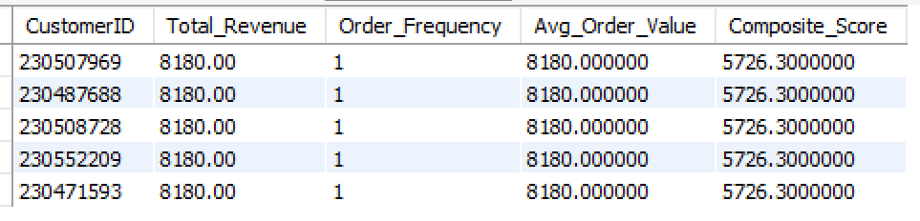
Above is the list of top 5 customers with high composite_Score and the results show that all the 5 customers have the same metrics in all aspects.

15. Calculate the month-over-month growth rate in total revenue across the entire dataset. (SQL)
Ans: To find month-over-month growth rate in total revenue I have grouped that data on “year-month” and then calculated monthly total revenue. The using the monthly total revenue I have found the previous month revenue using LAG() window function. Then using the monthly total revenue and previous month revenue I have calculate the growth rate.
Query:
with month_group as (
select
left(OrderDate, 7) as "Month",
SUM(SalePrice) as "Total_revenue"
from Orders
group by left(OrderDate, 7)
),
prev_data as (
select *,
LAG(Total_revenue) over(order by Month) as Previous_month_revenue
from month_group
)

select *,
round(((Total_revenue - Previous_month_revenue) * 100) / Previous_month_revenue, 2) as Growth_rate
from prev_data;
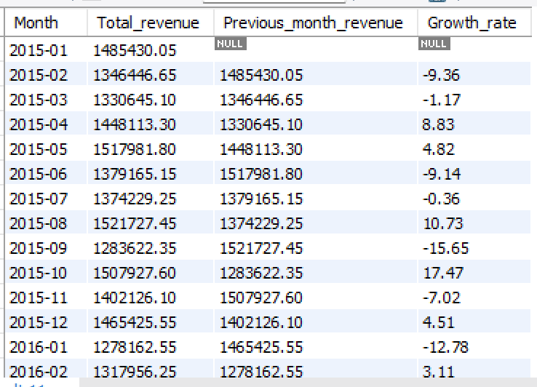

Output:

16. Calculate the rolling 3-month average revenue for each product category. (SQL)
Ans: To calculate the rolling 3-month average I have grouped the data on Product category and month-year to calculate total revenue. Then I have used AVG() OVER() window function to calculate rolling average between last 2 month and current month. Below is the query I have used.
Query:
with category_data as (
select
ProductCategory,
left(OrderDate, 7) as "Month",
SUM(SalePrice) as "Total_revenue"
from Orders
group by ProductCategory, left(OrderDate, 7)
)

select *,
round(AVG(Total_revenue) over(partition by ProductCategory order by month
rows between 2 PRECEDING and CURRENT ROW), 2) as Rolling_average_3_month
from category_data;
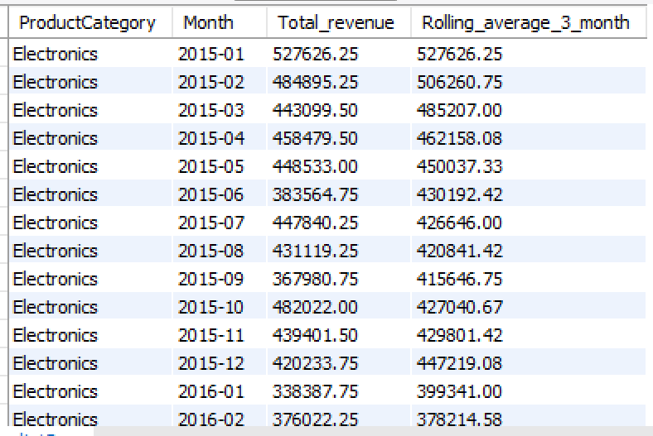
Output:

17. Update the orders table to apply a 15% discount on the `Sale Price` for orders placed by customers who have made at least 10 orders. (SQL)
Ans: Below is the query I used to update the orders table with discount of 15% for the customers how have placed at least 10 orders
Query:
with customer_list as (
SELECT CustomerID
from orders
group by CustomerID
having count(*) >= 10
)

UPDATE orders
SET SalePrice = SalePrice * 0.85
where CustomerID in (select * from Customer_list);
18. Calculate the average number of days between consecutive orders for customers who have placed at least five orders. (SQL)
Ans: To Calculate the average number of days between consecutive orders I have grouped data on CustomerID to count total orders placed and filtered customer who placed at least 5 orders. The found the days between each order placed by the qualifying customers using LAG() OVER() window function. Using the days between each order I have found the average no.of days between each order for each customer. Then found out the overall average days between consecutive orders by using AVG() on the above step. Below the query I have used to solve the question.
Query:
with qualify as (
select CustomerID
from orders
group by CustomerID
having COUNT(*) >= 5
),
Orders_data as (
select
CustomerID,
OrderDate,
DATEDIFF(OrderDate, LAG(OrderDate) over (
partition by CustomerID order by OrderDate
)) as day_diff
from orders
where CustomerID in (select CustomerID from qualify)
),
Average_data AS (
SELECT
CustomerID,
AVG(day_diff) AS avg_diff
FROM Orders_data
GROUP BY CustomerID
)

SELECT AVG(avg_diff) AS Average_days_between_orders
FROM Average_data;

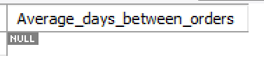
Output:
Output is null because there is no customer to placed at least 5 orders.

19. Identify customers who have generated revenue that is more than 30% higher than the average revenue per customer. (SQL)
Ans: To find the customers who have generated total revenue more then 30% than the average revenue by all customers, I have grouped data on CustomerID to calculate total revenue per each customer. Using the total revenue per customer I found the average revenue of all customers and filtered the customers who have generated 30% higher revenue in where clause and ordered the result by total revenue.
Query:
WITH Customer_data AS (
SELECT
CustomerID,
SUM(SalePrice) AS Total_revenue
FROM orders
GROUP BY CustomerID
)

select *
from Customer_data
where Total_revenue > ( select avg(Total_revenue) * 1.3 from Customer_data )
order by Total_revenue desc;
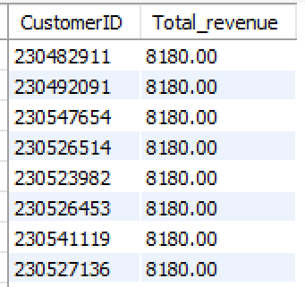
Output:

20. Determine the top 3 product categories that have shown the highest increase in sales over the past year compared to the previous year. (SQL)
Ans: To find the top 3 product categories that have shown the highest increase in sales over the past year compared to the present year, I have grouped data on ProductCategory and Year to find the yearly total sales of each product category for each year in a CTE. Then by using LAG() OVER() window function I retrieved previous year total sales in another CTE. In the last select statement I have subtracted the previous year sales from the current year sales and named as “sales_increase” and ordered the output in decreasing order of sales_increase” and used LIMIT 3 to show only top 3 product categories.
Query:
with year_sales as (
select
ProductCategory,
YEAR(OrderDate) As order_year,
SUM(SalePrice) as total_sales
from orders
group by ProductCategory, YEAR(OrderDate)
),
sales_growth as (
select *,
LAG(total_sales) OVER(partition by ProductCategory
order by order_year
) as previous_sales
from year_sales
)

select *,
(total_sales - previous_sales) as sales_increase
from sales_growth
order by sales_increase desc
limit 3;

Output:
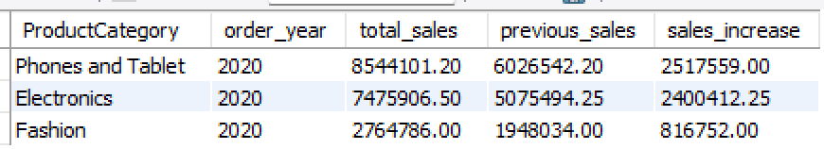

Subjective Question
1. Explain the revenue breakdown by year and by-product. Evaluate how different products contribute to annual revenue and come up with suggestions to increase the sales of the low-selling items.
Ans:
Approach:
- Build Line chart to show revenue breakdown by year from year 2015 to 2020.
- Build Bar chart to show the revenue breakdown by products which gives insights about which product contributed the most to the total revenue.
- Table visual was made to show revenue per year by prodcut which gives us the list of products with the least revenue generated.
Charts:
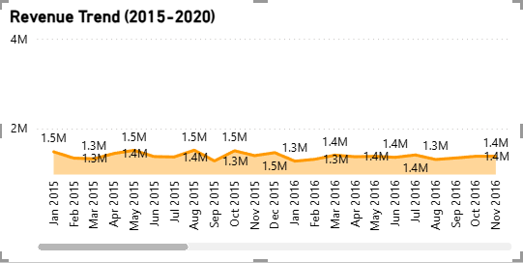
- Total Revenue by Year (Line chart)
- Total Revenue by Product (Bar chart)
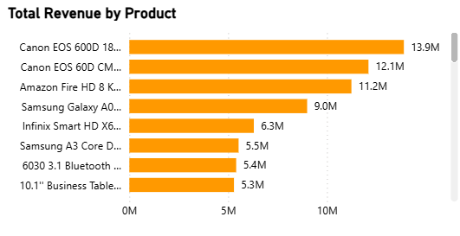

- Revenue by Product by Year (Table)
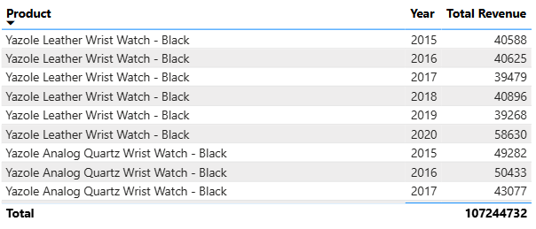
Insights:
- Conon 600D, Canon Eos 60D and Amazon fire HD were the product with highest revenue generated.
- From year 2015 to 2019 the total revenue was almost a straight line with not much devitation from the previous year but in 2020 their was a spike in the total revenue with almost 50% hike.
- Hemani Ultra Slime tea, Clera Radiance oil control Toner and Yazole Leather wrist watch are the least selling products over all the years
Recommendations:
- Pairing least selling products with high selling products ang giving extra discount on the combo high chances of increasing the sales.
- Promoting the least selling products in online platforms through ads and social media influencers will boost the sales.
- Increasing the visibility of the products in the amazon platform will increases the chances of customer purchasing it.
- Conduct surveys to gather the feedback of least selling products to find the route cause of the product failure.

2. How many products were returned? Use a DAX function to get this metric. Examine the possible reasons for returns and consider how this metric could indicate improvements in product descriptions or quality control.
Ans: To find the no.of products were returned I filtered out the rows where status is “Returned” and then used COUNTROWS() to count the products that are returned.
DAX: Total Returned Products = CALCULATE(COUNTROWS(Orders),
Orders[Status] = "Returned")
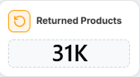
Output:

Insights:
- Total there are 31K orders which has been returned from 2015 to 2020.
- Health & Beauty and Fashions Product Category are the most returned products with 9.7k and 9k return orders.
- Electronics product Category was with the lowest return orders, that means electronic products were meeting the customer requirements.
Recommendtations:
- Focus on delivering High qualify product in every product category.
- Showing the exact photos of the product and display proper size charts.
- Maintaining the Quality of the product is important during any big sales events.
- Exact product description helps customers to know more about the products, and from the customers review the product quality and the drawbacks must be taken into considerations to design good products in the next slots.

3. Whenever a customer goes to Amazon, they’ll filter the most rated products to buy the better category. Can you verify this using any visualization or table that the ratings of products impact their sales value?
Ans:
Approach:
- To understand the relationship between rating and the products, I have taken total revenue per rating as a metric to see whether the high rating has high revenue or not.
- To understand in a better way I have also taken average product value per rating into consideration to understand the pattern.
- I have used Line with Column Chart to analyse the relation between rating and product sales, on x axis I have taken rating on the first y axis I have taken total revenue and on secondary y axis (line) I have taken average product price.

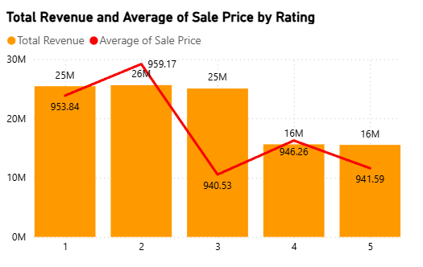
Chart:

Insights:
- From the graph we can see that the total revenue is higher for the low rating compared to high rating, this proves that high rated products doesn’t generate high sales revenue.
- When we consider average product value per rating it’s clear that there is not much of a difference in it, we can conclude that average product price has no effect on the rating.
- I have also observed that the returned products were of rating 1, 2 and 3, that means even after generating high revenue the return percentage is also high.
Recommendations:
- For products with rating 4 or 5 Amazon must run a special offer or combo deals to increase the sales volume, as the products has no return percentage customers will be happy with such products which is a plus point for the amazon.
- For products with rating 1 to 3 Amazon must focus on increasing the product quality and being transparent about the product to the customers so that the product return percentage decrease which increase the sales revenue.
- Identifying the high volume products and running deals and marking them as best value for money product on the home page will further increases the sales.

4. Investigate how revenue distribution varies across different locations. Explore which geographical areas contribute most to sales and consider the strategic implications for regional marketing and distribution efforts. How might location-based trends inform the company's market segmentation and resource allocation approach?
Ans:

Approach:
- I have used Treemap chart to analyse the revenue distribution across different loctions, the locations with most area covered are the locations with high sales revenue.
- As per the question I will focus on the top 5 locations to understand which geographical areas contribute most to sales.
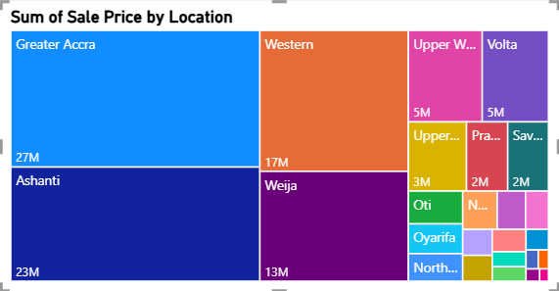
Chart:

Insights:
- Top 5 geographical locations with high revenue are Greater Accra, Ashanti, Western, Weija and Upper West.
- We can clearly say that the top 5 geographical locations total revenue is more then 70% of the total revenue across all the locations.
Recommendations:
- Amazon must keep focusing on Greater Accra and Ashanti locations as they are the leading revenue generators, they can introduce new products which are famous in the locations to run a experiment on the products.
- Amazon should plan to increase the sales of Western, Weija and Upper West by custom strategies as per the location customers likes and behaviour, so they can pair up the products with high volume sales with the low volume sales to increase the product popularity and sales revenue.
- Designing the strategies like promoting the products with the location top social media Influences to boost the overall sales in the top locations.

5. Determine which month could benefit from enhanced promotional offers to boost sales. Can you suggest some targeted marketing strategies here?
Ans:
Approach:
I have build monthly sales revenue chart to understand the revenue pattern over the month. I have used line chart to show time series data over month. I have taken order month on x axis and total revenue on the y axis.
Chart:
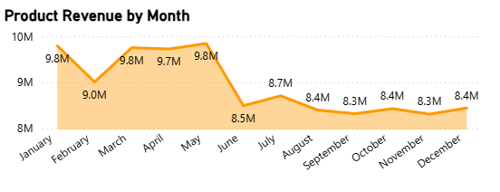
Insights:
- We can see that the revenue was high in the 1st half of the year which is a good sign for the Amazon it might be because amazon is running some sales and offers in the 1st half of the year which lead to higher sales.
- The revenue in the second half of the year was very low compared to the first half, Amazon must focus on the second half to keep up the sales up to the level of first half.
- In the first half amazon might have ran many kinds of sales, offers and major discounts so the sales were high.
- The lowest revenue was recorded in June and September with less then 7 million.
Recommendations:
- To increase sales in second half of the year amazon must keep running sales atleast higher then regular sales.
- Amazon must keep promoting user liked products, keep combo deals though out the year.
- Amazon must focus on regional festival sales, special discounts on the important days, like Christmas sales.
- Running sales deals on a particular days in each month, like deals on every first week of the month.
6. Identify which products may require increased marketing efforts. Which items have high prices yet underperform in sales?
Ans:
Approach:
To identify products having high prices with low sales (quantity) I have found the average unit price of all products and took products with unit price higher than the average. The products with less quantity sold are the underperforming products even having high price. To show the insights I have used column chart products with unit price higher than average unit price on x axis and total quantity sold on y axis. I have used visual filter to show only product with high unit price.
Chart:
Insights:
- The average unit price of all the products in amazon is 297.
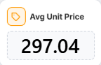
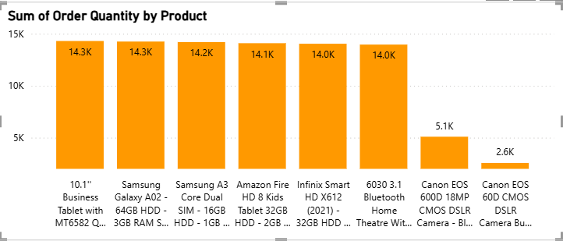
- From the chart we can see that Canon EOS 600D 18MP CMOS DSLR – Black and Canon EOS 60D CMOS Bundle – 18 – 55mm – Lens – Black are the 2 products with high unit price but with very less quantity sold.
- Other products with high unit price sales also higher which is positive point that is if the above mentioned two products are marketed properly they can perform better.
Recommendations:
- Running special discounts or pairing with high cost high value products will increase the sales volume of the two products.
- Promoting the products with influencers will boast both popularity and sales volumn.
- Increasing the visibility of those products on home page will attract more customers.
- Providing customers with EMI options will benefit both customers and amazon as the products are high cost, customers with budget issues maybe use EMI option to purchase them.

7. Assess which products should have discounts. How can targeted incentives drive sales and customer loyalty for specific products?
Ans:
Approach:
- I have selected products with unit price greater then 220 using visual filter and applied another filter to show only products with total quantity sold greater than 9000.
- It’s reasonable to give discounts on the high cost products which are also most sold so customers can buy their favorite products for less price.
- I have used bar chart to show case the analysis I wanted to do on the products which I recommend to increase the discounts.
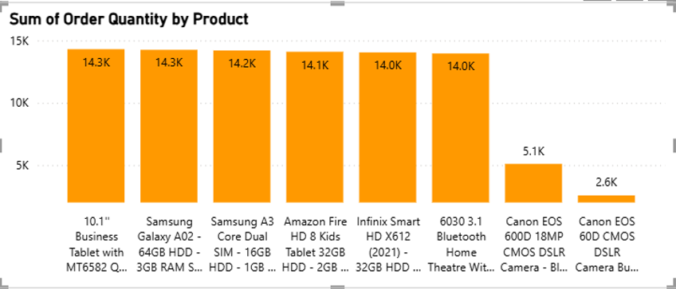
Chart:

Insights:
- From the chart we can see that there are 6 products with high cost and high quantity sold, which are perfect for giving more discounts to increase customer retention rate and sales of those products even further.
- We can observer that all the shown products have almost same unit price and same quantity ordered and all belongs to electronic and mobile category.

Recommendations:
- Products with unit price > 220 and high order quantity should receive limited-period discounts. This improves conversion rates and encourages repeat purchases without heavily impacting margins.
- Combine high priced popular products with accessories or complementary items at a discounted bundle price. This increases average order value and drives cross-selling.
- Give extra discounts, cashback, or reward points to repeat customers purchasing these products. This strengthens retention and builds long term customer loyalty.
- Target customers who previously viewed or purchased similar products with app/email offers. Personalized incentives improve engagement and increase the likelihood of purchase.

8. Come up with a loyalty program to benefit the company’s customers. From the available lot of customers come up with strategies to bucket them and provide benefits under different loyalty programs.
Ans:
Approach:
- Observing the data with the matrix total no of orders and total customers, there is only single order per each customers so we cant find insights based on customer purchase frequence.
- To solve this problem I have categorized customers into Platinum, Gold, Silver and Bronze based on the total purchase for each customer.
- If the purchase sales is greater then 5000 than Platinum, if greater then 300a than Gold, If greater then 1000 than Silver else Bronze.
DAX: Customer Category = IF(Orders[Sale Price] > 5000, "Platinum", IF(Orders[Sale Price] > 3000, "Gold", IF(Orders[Sale Price] > 1000, "Silver", "Bronze"))).
- I build customer category vs count of customers and customer category vs total revenue in order to understand the insights of each group.
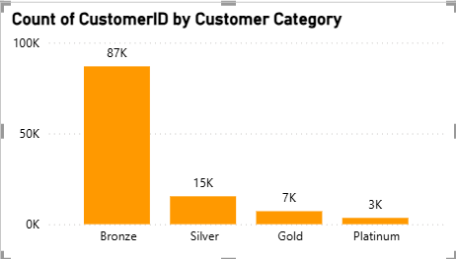
Chart:
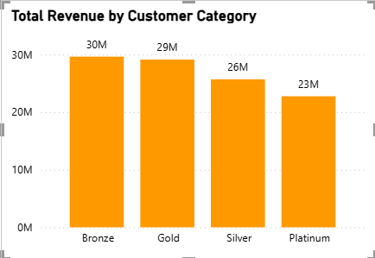
Insights:
- Bronze category has most of the customers, as the category level increases total customer count is the corresponding category was decreased.
- In Platinum category there are only 3k customer, in Gold category there are 7k customers which is of only 1% of total amazon customers.
- As we can see Platinum category as only 3k customers but the revenue generated by the customers is comparable to the bronze and silver category.
- Even after the bronze category having 87K customers the revenue generated is low compared to the count of customers.
- Gold and Silver have less customers but the revenue gererated is high with 29.1M and 25.7M.
Recommendations:
- Amazon must focus on Bronze category customers in order to convert them at least to the silver category, with the help of personalized discounts, coupons and paired with low value products with high value products.
- Analyzing Gold customers is very important as there are very high chances of conversation to Platinum customer which boast revenue a lot.
- Amazon also must focus on retention of Platinum customers to keep them engaging with new and popular items with high costs, through this amazon keep earning from the platinum customers.

9. Using the DAX functions Calculate and a row iteration DAX function calculate the total sales for the Product Category “Fashion” and delivery type “Shipped from Abroad”. What are the other types of DAX functions you have used in the project?
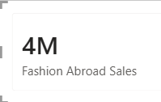
Ans: To calculate total sales for Product Category “Fashion” and delivery type “Shipped from Abroad”, I have used CALCULATE() function so that I can apply condition on the calculation, with the help of FILTER() I have filtered only Product Category “Fashion” and delivery type “Shipped from Abroad”.
Total sales for Product Category “Fashion” and delivery type “Shipped from Abroad” is 4 M.
Other DAX functions I have used:
- I have used aggregation DAX functions to calculate total revenue, Total returned product, Unique customers, Unique products etc.
- Used DAX to create calculated columns like Delivery days and customer Category using functions like DATEDIFF() AND IF().

10. Wait Times Correlated with Demographics and Care: Explore how average wait times vary across different product categories to optimize scheduling and staffing.
Ans:
Approach:
- To calculate wait time I have used DAX function DATEDIFF() on order data and delivery date.
DAX: Delivery Days = DATEDIFF(Orders[OrderDate], Orders[Delivery Date], DAY)
- Now to find out average wait time across different products I have used Line chart, on y axis I have taken Average delivery days and on x axis I have taken product categories.
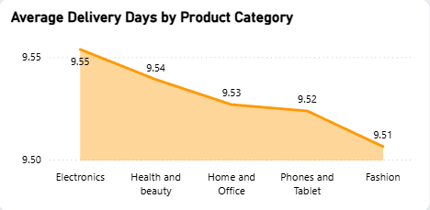
Chart:
Insights:
- We can clearly see that for all the product categories the average wait days is equal that is approx 9.5 days.
- The delivery wait time is consist across all product categories that shows equal importance for all the categories.
Recommendations:
- Decreasing the delivery wait time with the help of express delivery service which atleast decrease the delivery days by 2 days which will be a great improvement.
- Focusing more on the categories with high sales will increase customer satisfaction by delivering them faster then other.
- Increasing the warehouses in the main cities will impact on the wait time for sure, maximum products will be delivered within 4 to 5 days within same city.

11. Explore if there is any relationship between the Delivery type and waiting time between ordering and receiving an item.
Ans:
Approach:
- To calculate wait time I have used DAX function DATEDIFF() on order data and delivery date.
DAX: Delivery Days = DATEDIFF(Orders[OrderDate], Orders[Delivery Date], DAY)
- I have used column chart to understand the relationship between delivery type and waiting time. Delivery type on x axis and delivery wait time on y axis.
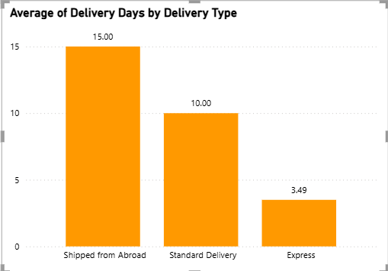
Chart:
Insights:
- Express delivery being the fast delivery type with just 3.5 days as average, and the average shipping cost is also the same as other two delivery types.
- As the name says Shipped from Abroad is the most longest waiting time delivery type with 15 days, which is acceptable for international orders.
- Standard delivery type takes on average of 10 days to delivery the order which is little too much time and the shipping cost is same as Express so customers might be dissatisfied in this field.

12. Is there any relationship between shipping charges and product type?
Ans:
Approach:
To find out the relationship between shipping charges and product type I have used Bar chart, product category on the y axis and the average shipping charges on the x axis. The chart will let us understand the pattern between them.
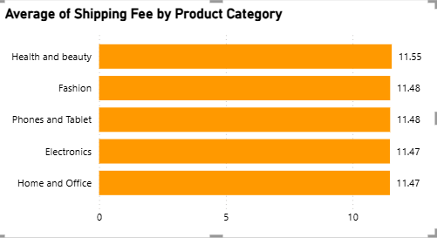
Chart:
Insights:
- As we can see for all the product categories have the same average shipping costs, which is amazing thing giving equal importance to all the categories.
- According to me Home and Office categories must have little higher shipping cost because the weight of products in this category will be more then the other category.
- Just by observing the chart we can say that there is no relationship between product category and the shipping cost.

13. Come up with strategies to decrease the low rating orders after analyzing different factors like waiting time, shipping type, unit price, etc.
Ans:
Approach:
To identify the factors contributing to low-rated orders, I analyzed orders with ratings of 1, 2, and 3. Different visualizations were used to evaluate the impact of delivery type, waiting time, and product pricing on customer ratings.
- A Column Chart was created to compare the Average Rating by Delivery Type, using Delivery Type on the X-axis and Average Rating on the Y-axis, while applying a visual filter for ratings below 4.
- Another Column Chart was used to analyze the relationship between Average Delivery Days and Ratings, with Rating on the X-axis and Average Delivery Days on the Y-axis.
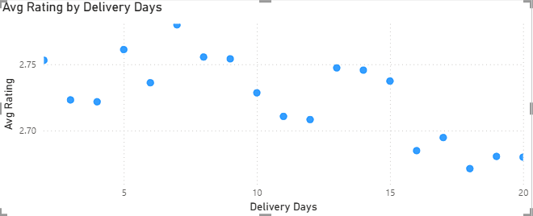
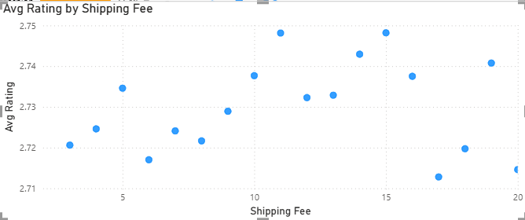
A Scatter Chart was created to study the relationship between Unit Price and Ratings, helping determine whether product pricing influences customer satisfaction.
Charts:

Insights:
- The analysis shows that the average rating across different delivery types is almost similar, indicating that delivery type alone does not significantly impact customer ratings.
- The average delivery time remains relatively consistent for low-rated orders, suggesting that waiting time is not the primary reason behind poor ratings in this dataset.
- The scatter plot between Unit Price and Rating does not show any clear correlation, indicating that customers are not necessarily giving lower ratings to higher-priced products.
- Based on the visual analysis, low ratings appear to be more closely associated with product quality issues, inaccurate product descriptions, unmet customer expectations, or product defects, rather than shipping method, delivery speed, or productprice.
- Recommendations:
- Improve Product Quality Control
- Conduct stricter quality checks before dispatch.
- Monitor products with consistently low ratings and high return rates.
- Enhance Product Descriptions
- Provide accurate specifications, dimensions, features, and realistic product images.
- Avoid exaggerated marketing claims that create unrealistic customer expectations.
- Leverage Customer Feedback
- Regularly analyze reviews and ratings to identify recurring complaints.
- Use feedback to improve products and supplier performance.
- Strengthen Seller Monitoring
- Track seller performance and take corrective actions against sellers with poor customer satisfaction scores.
- Focus on High-Value Products
- Premium-priced products should maintain superior quality standards to justify their pricing and improve customer satisfaction.
- Improve Post-Purchase Support
- Offer faster issue resolution, replacement options, and responsive customer service to reduce customer dissatisfaction.

14. Using the time intelligence DAX function, create a table to compare each month’s sales with the previous year’s same month’s total sales. So there will be four columns in the output year, month, total sales, previous_years_sales.
Ans:
Approach:
- A Calendar table was created and connected with the Orders table through the OrderDate field.
- A Total Revenue measure was created using the SUM() function.
- The SAMEPERIODLASTYEAR() Time Intelligence function was used to calculate sales from the corresponding month of the previous year.
- A table visual was created containing Year, Month, Total Revenue, and Previous Year Sales to compare monthly sales performance across years.
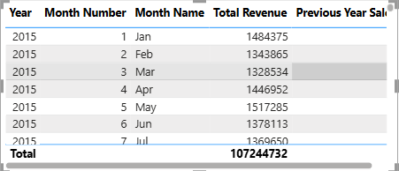

Chart:

Insights:
- The comparison helps identify year-over-year sales growth and seasonal patterns.
- Management can easily compare current month performance with the same month from the previous year.
- This analysis helps evaluate the effectiveness of promotional campaigns, pricing strategies, and business growth over time.
- Months showing significant growth can be further analyzed to identify successful business initiatives, while months with declining performance may require targeted interventions.
15. What do you understand by PowerBI gateway? What are its use cases?
Ans: Power BI Gateway is a bridge that connects Power BI service (cloud) with data stored in local systems like on-premise servers, SQL databases, Excel files, or internal company networks. It allows Power BI to access and refresh data securely without moving the entire database to the cloud.
In simple terms, when a company keeps its data inside its own system but wants to create dashboards in Power BI Service, the gateway helps Power BI pull that data and keep reports updated.
Use cases:
- To automatically refresh Power BI dashboards using data stored in local databases.
- To securely connect on-premise data sources with Power BI cloud.
- To schedule data refresh without manual file uploads.
- To enable real-time reporting when business data is stored inside company servers.
- To maintain data security while still using cloud-based analytics.

16. How would you approach this problem, if the objective and subjective questions weren't given?
Ans: Approach:
If the objective and subjective questions were not provided, I would follow a structured data analytics approach to identify key business insights and improvement opportunities.
Step 1: Data Understanding
- Review the dataset structure, columns, and business context.
- Understand customer, product, delivery, and sales-related attributes.
Step 2: Data Cleaning
- Handle missing values and inconsistencies.
- Verify data types and relationships.
- Remove duplicates and ensure data quality.
Step 3: Exploratory Data Analysis (EDA)
- Analyze revenue trends over time.
- Study customer purchasing behavior.
- Evaluate product performance and category-wise sales.
- Investigate return rates and customer ratings.
- Examine delivery performance and shipping costs.
Step 4: KPI Creation
Create key business metrics such as:
- Total Revenue
- Total Orders
- Unique Customers
- Customer Satisfaction Rating
- Return Rate
- Average Delivery Days
- Product Performance Metrics
Step 5: Dashboard Development
Design interactive dashboards for:
- Executive Overview
- Product Analysis
- Customer Analysis
- Delivery Performance
Step 6: Business Insights & Recommendations
Identify:
- Top-performing products
- Underperforming products
- High-value customers
- High-return categories
- Regional sales opportunities
Based on the findings, recommend:
- Customer loyalty programs
- Product improvement strategies
- Targeted marketing campaigns
- Delivery optimization initiatives
- Pricing and discount strategies
Conclusion:
By following this structured analytical process, meaningful insights can be generated even without predefined questions. The focus would be on identifying revenue growth opportunities, improving customer satisfaction, optimizing product performance, and supporting data-driven business decisions.
